**15_3_22 Marlese Meiring Statistical procedure for Table A2**

Julle beskrywing van julle proef vir Table A2 en anova van Tabel A2 stem nie ooreen nie

Verder kyk ek weer na Appendix en sien diemooi duidelike skets is pragtig, maar hulle anova (Table A2) is nie so gedoen nie

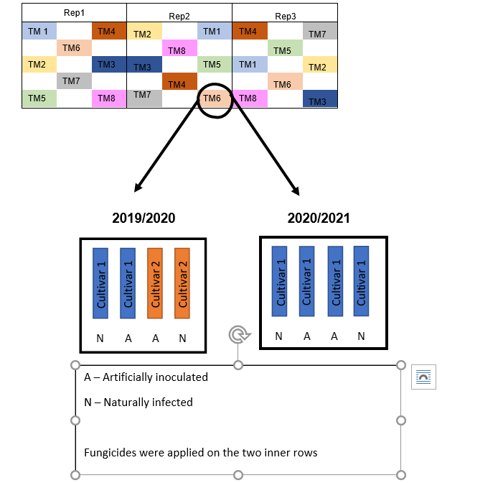

**Vir hierdie skets 2019/2020 moet anova so lyk:**

|  |  |
| --- | --- |
| **Sources of Variation** | **DF** |
| **Rep** |  |
| **TM** | **Mainplot** |
| **Err(a)=Rep*TM** |  |
| **Cult** | **Subplot** |
| **Cult*TM** |  |
| **Err (b) Rep*Cult*TM)** | **As julle gesplit het,** |
| **Inoc** |  |
| **Inoc*TM** |  |
| **Inoc*Cult** |  |
| **Inoc*TM*Cult** |  |
| **Error(c) =Rep*Inoc*Cult*TM** |  |

Julle het TM verdeek in 2 Cult is ek reg? As ek na prentjie kyk nie Cult gesplit nie

AS Cult gesplit was sou Cult A so gelyk Julle het Cult in 2 gedeel een deel kry N en een kry A. Ons kan more daaroor gesels

|  |  |
| --- | --- |
| N | A |

Hoekom het julle Planting dates as blokke gebruik (Table A2) en in Table A3 is daar skielik herhalings/blokke hoe werk dit?

**As ek na die anova (Table A2) kyk is die onderstaande beskrywing meer korrek.**

The experimental design was a randomised block design with 2 planting dates as blocks. The treatment design was a spilt-split plot design with cultivar (cult A and cult B) as main plot, inoculation treatment (natural and artificial) as subplot factor and 9 fungicide treatment as sub- subplot factor

Vanuit Table A2 is daar geen betekenisvolle interaksies met cult dus gooi hulle die data saam en doen anova Table A3 Nou het hulle binne elke plant datum herhalings hoe werk dit?

Vir Table A3 hier is julle beskrywing vir ANOVA tabel reg maar ek sou PDates gekombineer want as ek reg is ,word n hele proef op n spesifieke plant datum gedoen Die anova lyk ietwat anders.

Each season was separately analysed as a split-split plot with the planting dates as the whole plot, the inoculations (artificial or natural) as sub plot and the fungicides applied as the sub-sub plot. However, each planting date of each season was also analysed separately as a split plot, with the inoculations as the whole plot and fungicides applied as the sub plot factors. Means were separated using Fisher’s least significant differences (LSD; α = 0.05). Pearson correlation coefficients were applied to illustrate the relationship between Sclerotinia disease and sclerotia incidence, as well as Sclerotinia disease incidence and soybean yield

**Table A2:** Split-split plot analysis of variance indicating the effect of several fungicides on Sclerotinia stem rot due to both natural and artificial infections on soybeans planted in the 2019/2020 season at two planting dates, 09 November 2019 and 26 November 2019, in Delmas. The two soybean cultivars used in this season were harvested together, and consequently there was a need to combine the other two response variables i.e., Sclerotinia disease incidence and sclerotia incidence of the two cultivars.

|  |  |  |  |  |  |
| --- | --- | --- | --- | --- | --- |
| ~~Split-split plot~~ Sources of variation | Degrees  of  freedom | Sum  of  Squares | Mean Square | F value | Probability (>F) |
| Planting date | 1 | 6267.347 | 6267.347 | 42.554 | 0.000 |
| Cultivar | 1 | 80.967 | 80.967 | 50.231 | 0.089 |
| Error (a) | 1 | 1.612 | 1.612 |  |  |
| Inoculated | 1 | 31416.673 | 31416.673 | 10.265 | 0.085 |
| Cultivar:inoculated | 1 | 65.226 | 65.226 | 0.021 | 0.897 |
| Error (b) | 2 | 6121.157 | 3060.578 |  |  |
| Treatment | 8 | 6491.601 | 811.450 | 8.556 | 0.000 |
| Treatment:cultivar | 8 | 600.501 | 75.063 | 0.791 | 0.614 |
| Treatment:inoculated | 8 | 6395.016 | 799.377 | 8.428 | 0.000 |
| Treatment:cultivar:inoculated | 8 | 677.993 | 84.749 | 0.894 | 0.533 |
| Error (c) | 32 | 3035.018 | 94.844 |  |  |

**Table A3:** Split-split plot analysis of variance indicating the effect of several fungicides on Sclerotinia stem rot due to both natural and artificial inoculations on soybeans planted in the 2019/2020 season at two planting dates, 09 November 2019 and 26 November 2019, in Delmas.

|  |  |  |  |  |  |
| --- | --- | --- | --- | --- | --- |
| ~~Split-split plot~~ Sources of variation | Degrees  of  freedom | Sum  of  Squares | Mean Square | F value | Probability (>F) |
| Rep | 2 | 146.216 | 73.108 | 0.450 |  |
| Planting date | 1 | 2400.000 | 2400.000 | 14.775 | 0.062 |
| Error (a) | 2 | 324.872 | 162.436 |  |  |
| Inoculated | 1 | 12053.763 | 12053.763 | 104.383 | 0.001 |
| Planting date:inoculated | 1 | 2457.483 | 2457.483 | 21.281 | 0.010 |
| Error (b) | 4 | 461.905 | 115.476 |  |  |
| Treatment | 7 | 2456.441 | 350.920 | 3.474 | 0.004 |
| Treatment:planting date | 7 | 392.177 | 56.025 | 0.555 | 0.789 |
| Treatment:inoculated | 7 | 2478.720 | 354.103 | 3.506 | 0.003 |
| Treatment:planting date:inoculated | 7 | 380.952 | 54.422 | 0.539 | 0.801 |
| Error (c) | 56 | 5656.122 | 101.002 |  |  |